NAME:-MUNAGAPATI.BHARGAV

REGISTERED NUMBER:-192111375

SUBJECT:-SOFTWARE ENGINEERING WITH AI TECHNIQUES

SUBJECTCODE:-CSA1OO1

FACULTY:-DR.G.MARY VALANTINA

EXPERIMENT-11

DATE:-28-09-2022

AIM:- To draw CLASS DIAGRAM diagram for ONLINE VOTING SYSTEM using umbrello

DIAGRAM:-

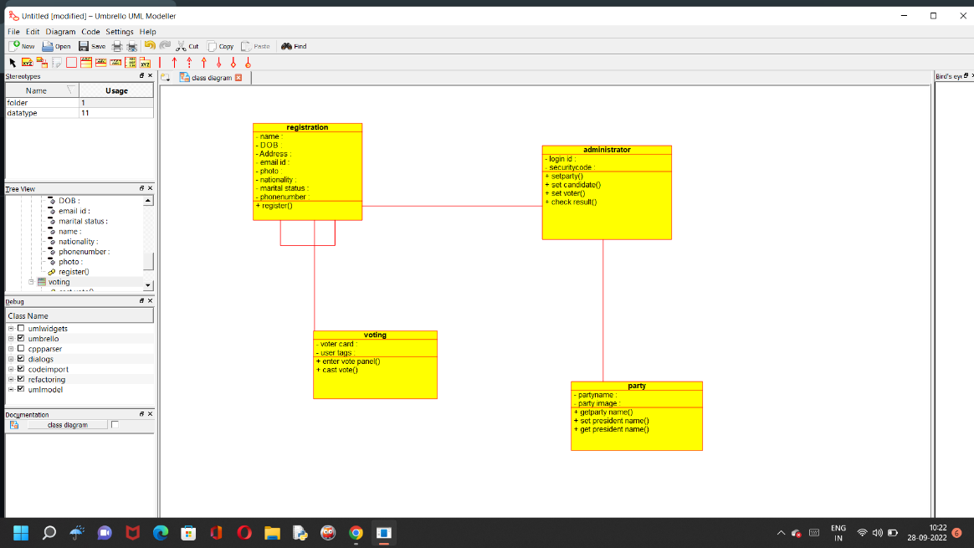

RESULT:- SSuccessfully done the CLASS DIAGRAM of ONLINE VOTING SYSTEM in umbrello software

EXPERIMENT-12

DATE:-28-09-2022

AIM:- To draw CLASS DIAGRAM diagram for LIBRARY MANAGEMENT SYSTEM using umbrello

DIAGRAM:-

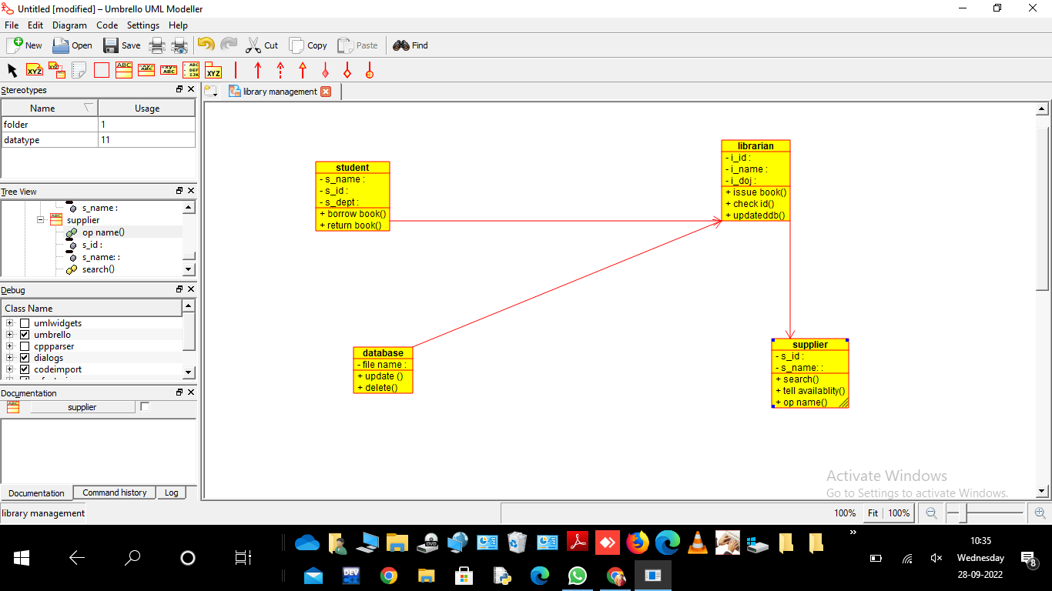

RESULT:- SSuccessfully done the CLASS DIAGRAM of LIBRARY MANAGEMENT SYSTEM SYSTEM in umbrello software

EXPERIMENT-13

DATE:-28-09-2022

AIM:- To draw CLASS DIAGRAM diagram for ONLINE SHOPPING SYSTEM using umbrello

DIAGRAM:-

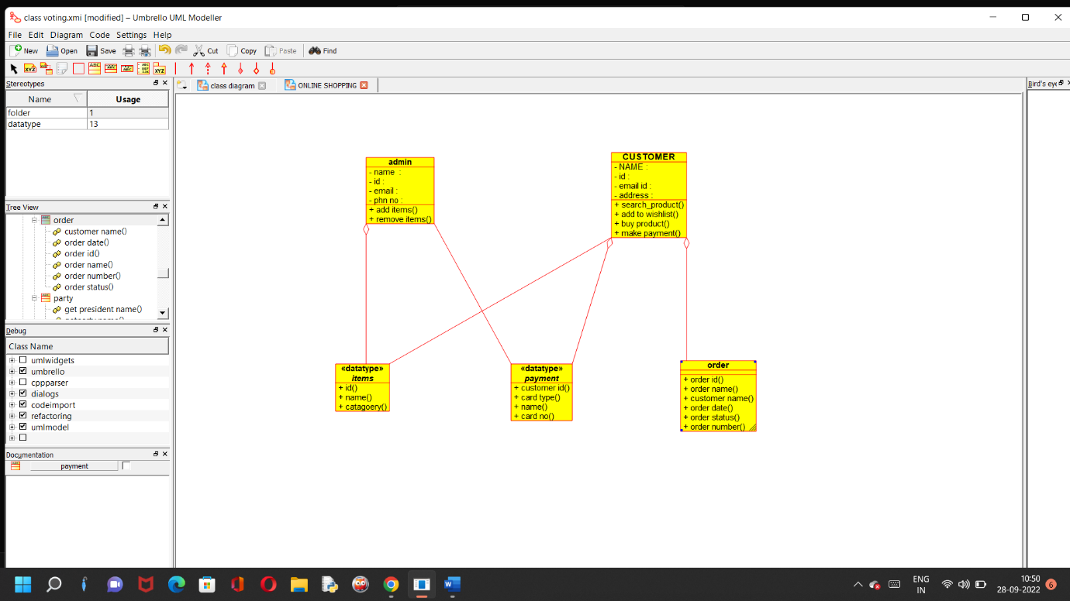

RESULT:- SSuccessfully done the CLASS DIAGRAM of ONLINE SHOPPING SYSTEM in umbrello software

EXPERIMENT-14

DATE:-28-09-2022

AIM:- To draw CLASS DIAGRAM diagram for ONLINE RAILWAY RESERVATION SYSTEM using umbrello

DIAGRAM:-

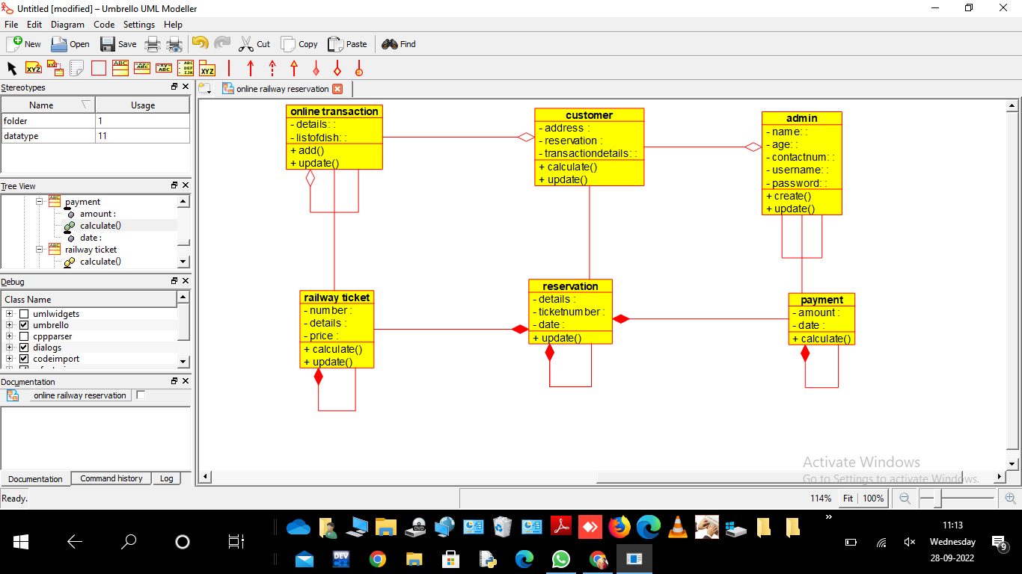

RESULT:- SSuccessfully done the CLASS DIAGRAM of ONLINE RAILWAY RESERVATION SYSTEM in umbrello software

EXPERIMENT-15

DATE:-28-09-2022

AIM:- To draw ACTIVITY DIAGRAM diagram for ONLINE VOTING SYSTEM using umbrello

DIAGRAM:-

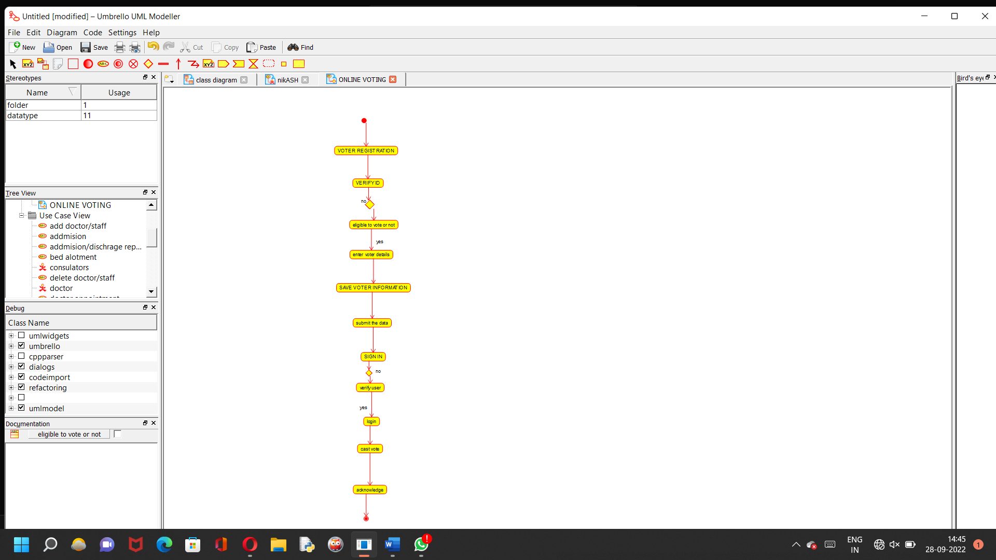

RESULT:- SSuccessfully done the ACTIVITY DIAGRAM of ONLINE VOTING SYSTEM in umbrello software

EXPERIMENT-16

DATE:-28-09-2022

AIM:- To draw ACTIVITY DIAGRAM diagram for LIBRARY MANAGEMENT SYSTEM using umbrello

DIAGRAM:-

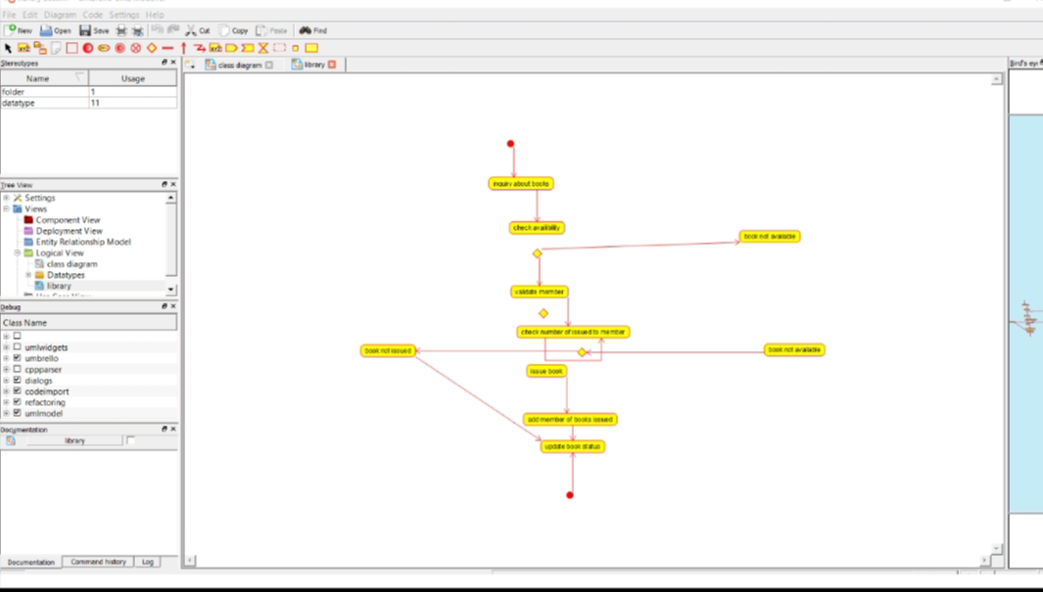

RESULT:- SSuccessfully done the ACTIVITY DIAGRAM of LIBRARY MANAGEMENT SYSTEM in umbrello software

EXPERIMENT-17

DATE:-28-09-2022

AIM:- To draw ACTIVITY DIAGRAM diagram for ONLINE SHOPPINNG SYSTEM using umbrello

DIAGRAM:-

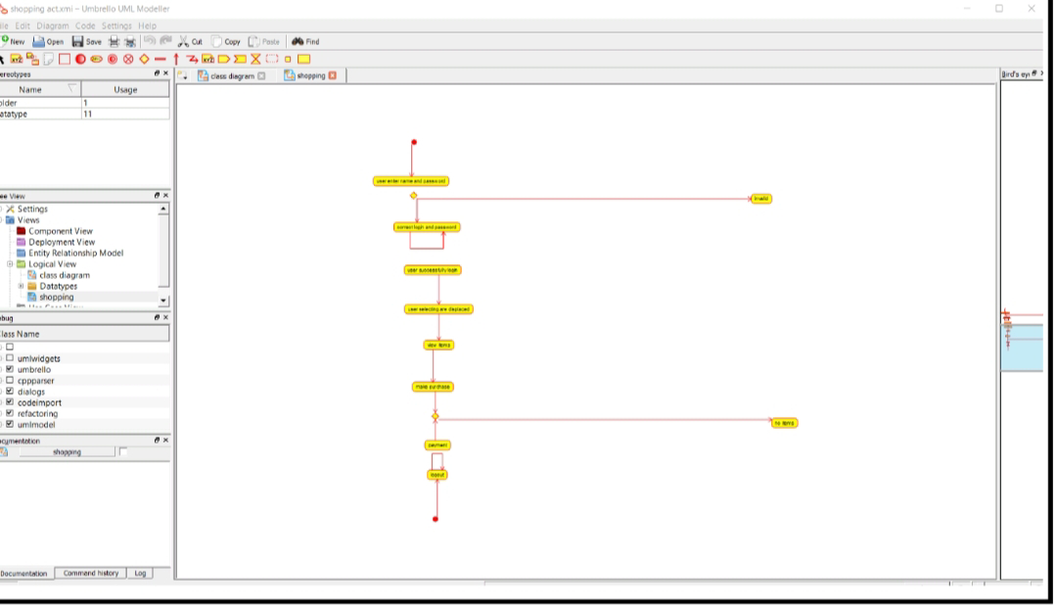

RESULT:- SSuccessfully done the ACTIVITY DIAGRAM of ONLINE SHOPPINNG SYSTEM in umbrello software